Monitoring Biodiversity in the LTAR network

Contributors: Betsey Boughton, Raoul Boughton, Alisa Coffin, Lauren Porensky, David Augustine, Phil Fay, John Sadler, Chris Bobryk

**Background**

1. Biodiversity is declining worldwide at an unprecedented rate. Biodiversity is important for agriculture for improved functioning, but agriculture can be important for biodiversity by maintaining habitats such as grasslands and woodlands (Moonen and Barberi 2008; Fabian et al. 2013). Site based research is important for understanding mechanisms, but there is increasing evidence from invertebrate studies that large-scale research across agro-ecosystems is crucial to advance our understanding of declining biodiversity and eco-systems services provided by biological control agents (e.g. Bianchi et al. 2006, Tscharntke et al. 2007, Thies et al. 2011, Werling et al. 2011, Avelino et al. 2012, Woltz et al. 2012, Fabian et al. 2013, Liu et al. 2014). Long-term observations are required to detect changes in biodiversity due to climate change, landuse change or changes in management. A rich literature shows strong responses of several measures of biodiversity to changes in agroecosystem management. Organisms (abundance) that have been shown to respond to agricultural practices include birds, predatory and non-predatory insects, soil organisms, and plants (Bengtsson et al. 2005, Geiger et al. 2010, Hendrickx et al. 2007, Donald et al. 2001, Sotherton et al. 1998, Werling et al. 2014).

2. Capturing the biodiversity of a site is extremely labor intensive and requires significant expertise. Populations of species are not easily measured with fixed instruments, and species populations fluctuate naturally under the influence of environment and life history traits (e.g. resources, predators, competition and disease, voltism, aestivation). Therefore a major goal is to select sentinel metrics of biodiversity, that can be measured at all sites. Research has shown that different taxa and trophic levels do not always respond similarly to variation in land use (Werling et al. 2014, Medley et al. 2015). Therefore, sampling sentinel taxa from multiple trophic levels across land-use types is important to gain a more complete understanding of biodiversity dynamics.

3. The importance of climate, landscape diversity and topographic heterogeneity should be captured as these factors drive biodiversity. These large scale attributes define the biodiversity “potential” of a site and can be coupled with site specific smaller scale metrics to explain biodiversity dynamics (Fig. 1). For example, croplands embedded in larger forest systems compared to croplands embedded within croplands will have very different bird, insect, and plant diversity.

4. According to NatureServe, the key to creating interoperability among a network is the use of a rigorous set of field and data management standards and protocols. We require a “common language” that allows us to truly function as a cohesive network in monitoring biodiversity. Therefore, it is important to have a standardized set of methods and indicators for biodiversity across the LTAR network. To leverage extensive development of protocols already undertaken by NEON, we propose to select a subset of NEON sentinel taxa across trophic levels for inclusion in the biodiversity component of LTAR monitoring. A second purpose for using the same sentinel indicators and protocols is that the NEON sites can represent a reference site for comparison to LTAR agroecosystems. We suggest that soil microbes, plant diversity, insect diversity, and breeding landbird diversity will be the most relevant to LTAR, the most tractable metrics of biodiversity, and applicable to a wide array of other measurements that LTAR is undertaking including productivity, biomass, fluxes and phenology. *insect sampling protocol differs from NEON due to importance of different insect groups to agro-ecosystems.

**Temporal and Spatial Scale**

Spatial: Ability to scale from plot to watershed scale will depend on how many habitats are sampled with plots. Minimum sampling effort will include the experimental treatments in the Common experiment (Fig. 1).

Temporal: Measurements need to match highest potential time periods for detecting diversity of sentinel organisms. Eg. Peak flowering for plants, peak breeding for birds, peak growing season for microbes.

Table. 1. Minimum periodicity of sampling.

|  |  |  |  |  |
| --- | --- | --- | --- | --- |
|  | **Spring** | **Summer** | **Autumn** | **Winter** |
| **Soil Microbes** | **x** | **X** | **x** |  |
| **Plant Diversity** | **x** |  | **x** |  |
| **Landbird Diversity** | **x** | **X** |  |  |
| **Inverts/Pollinators** | **x** | **X** |  |  |

**Conceptual Plan to Sample Biodiversity**

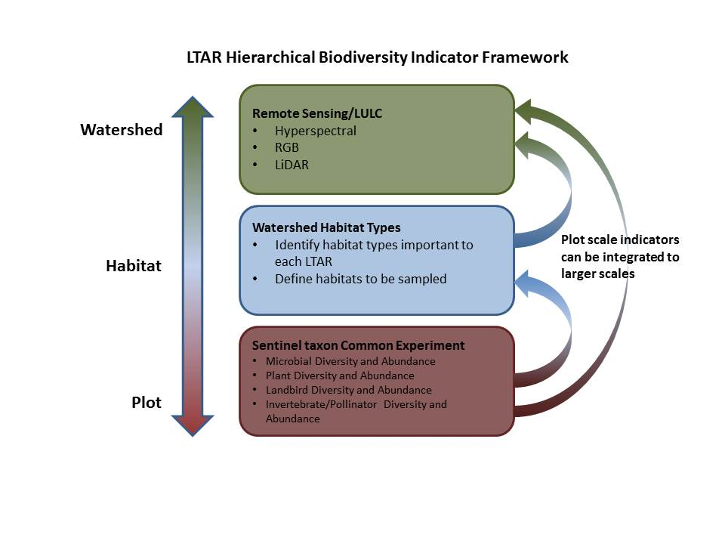

Fig. 1. Hierarchical biodiversity indicator framework from plot to watershed scale. Remote sensing products will provide large scale drivers of biodiversity. Habitat types important to individual LTAR sites will be identified for plot scale sampling of sentinel taxon. Minimum biodiversity indicator sampling will occur within the Common Experiment footprint.

**Objectives** Biodiversity assessment and monitoring at LTAR sites fundamentally relates to both the observational and experimental dimensions of the LTAR network.

A critical component of the biodiversity monitoring is to characterize landscape diversity, topographic heterogeneity, and dominant vegetation cover annually for each LTAR site. (this can be immediately collected)

In the context of the Observatory component of LTAR, the purpose of biodiversity sampling is to describe sentinel taxon that are comparable across LTAR sites and relevant to other networks, such as NEON. Collaboration with other networks will allow greater understanding of continental trends in biodiversity influenced by agroecosystems. In some cases, other networks may act as a reference site for agroecosystems.

In the context of the Common Experiment, the goal of biodiversity monitoring is understand how biodiversity responds to aspirational management vs. conventional ag.

**Suggested Biodiversity measurements**

1. Characterize landscape diversity and dominant vegetation for each LTAR using remote sensing. Use airborne remote sensing to make annual measurements of 1) land cover and land use, 2) vegetation cover and dominant vegetation type, 3) Vegetation structure including height and LAI, 3) vegetation condition, 4) Vegetation biochemistry and heterogeneity, 5) canopy chemistry (Nitrogen index), 6) topography (elevation, slope, aspect), and 6) Vegetation greenness and health ([www.neoninc.org/science-designt/collection-methods/airborne-remote-sensing](http://www.neoninc.org/science-designt/collection-methods/airborne-remote-sensing)). Could leverage NEON airborne protocols to achieve this. (Could look into having the NEON Airborne Observation Platform include LTAR sites in their annual flights). Importantly, LiDar and other remote sensing techniques have been found to be surrogates for biodiversity(Wallis et al. 2016)
2. Standardized biodiversity sampling of sentinel taxon: soil microbes, plant diversity, breeding landbirds (see attached NEON protocols), and insects (herbivorous, predatory, pollinators). Sampling plant, bird, and insect diversity in croplands may be most relevant in non-crop areas such as fallow fields , hedgerows, edge habitats, or embedded natural habitats.

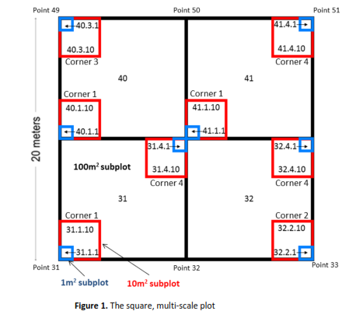**Logistics**

**Soil Microbe Diversity –** to be developed by Hal Collins, Jude Maul, Brekke Peterson-Munks. Should be comparable to NEON.

**Plant Diversity – NEON:** 400 m2 Whittaker plots, expected to take between 1-4 hours per plot to perform after initial set-up. # of plots will depend on the spatial variation (stratified by habitat) that is desired to be sampled, but will probably be 5-10 plots in each habitat type sampled. Sampling will take place during peak flowering periods when plant identification is easiest. This may be 1 or 2 times annually (spring and autumn flowering periods).

Other option: The Whittaker plot approach may be time consuming and may not be the best approach in fragmented systems. An alternative would be to have plots that are 100 m2 and 1 m2 stratified by habitat. We need to choose the size of plot we think is most representative of the most plant diversity and it is important that as a minimum all LTAR sites have plant diversity from the same size of plot (100 m2?); while other sites could also measure plant diversity in other size plots if they desired. Plant cover would be estimated in 1 m2 plots, whereas in the 100 m2 plots, plant species presence would be recorded.

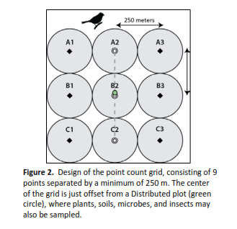**Breeding Landbird Diversity (NEON)–**Breeding landbirds will be sampled using the point count method. Point counts will have a 2 minute settling period followed by a six minute timed observation period where birds observed or heard are marked for each minute for sampled. Points counts will be arrayed in a 3 x 3 grid, with each point separated by 250 m. Five of the arrays will be completed in each habitat type over a period of 5-14 days, once or twice during the breeding season. Sampling will occur 30 minutes before sunrise and 3-4 hours after sunrise. A grid will take approximately 2 hours for an experience person to complete. Generally, only 1 or 2 grids could be done in a day.

**Invertebrate Diversity –** Insects will be sampled with sweep nets. In each field, 2 sweep transects of 50 m in length will be conducted at the center of the field: one running to the north and one to the south. Each of the two sweep sample transects will consist of 50 sweeps taken while slowly moving to the plot center. Both of the transect samples will be combined, sealed in plastic bags and transferred to 90% ethanol solution for storage. Insects will be identified to family level and placed in functional groups: decomposers, fungivores, sap and wood feeders, herbivores, predators, parasites, parasitoids, and pollinators).(Robertson et al. 2012).

Other option: Modify this protocol if vegetation structure is not conducive to sweep netting. For example cotton is best sampled with beat cloths.

**Alternative Approaches to Point Counts**

*Soundscape analyses*

* Avian point counts and invertebrate sweep net sampling can be extremely time consuming. Acoustic sampling techniques are a potential alternative to point counts
* Acoustic diversity and evenness indices can be used to understand animal diversity in different habitats and in response to human impacts and climate drivers
* Analytical techniques have been developed to analyze entropy, dissimilarity, shannon’s diversity, and complexity (using R, seewave and soundecology). Acoustic complexity index can be analyzed with separate plugin. The analytical technology is still developing.
* Measure with Song Meter SM2+. Base price is $769 but there are various accessories required and fully functional unit would be $1,100. <http://wildlifeacoustics.com/store?slider2=song-meter-sm2#song-meter-sm2>
* Potential cons is that this generates are large amount of data and manual listening can be a way to aurally validate and critical post-processing step.

**References**

Avelino, J., A. Romero-Gurdian, H. F. Vruz-Cueller, and F.A.J. Declerck. 2012. Landscape context and scale differentially impact coffee leaf rust, coffee berry borer, and coffee root-knot nematodes*. Ecological Appliactions 22(2),* 584-596.

Batáry, P., Báldi, A., Kleijn, D., & Tscharntke, T. (2011). Landscape-moderated biodiversity effects of agri-environmental management: a meta-analysis. *Proceedings of the Royal Society of London B: Biological Sciences*, *278*(1713), 1894-1902.

Bengtsson, J., Ahnström, J., & WEIBULL, A. C. (2005). The effects of organic agriculture on biodiversity and abundance: a meta‐analysis. *Journal of applied ecology*, *42*(2), 261-269.

Bianchi, F.J.J.A., C.J.H. Booij, and T. Tscharntke. 2006. Sustainable pest regulation in agricultural landscapes: a review on landscape composition, biodiversity and natural pest control. *Proceedings of the Royal Society B 273*. 1715–1727

Butler, S. J., Brooks, D., Feber, R. E., Storkey, J., Vickery, J. A., & Norris, K. (2009). A cross‐taxonomic index for quantifying the health of farmland biodiversity. *Journal of Applied Ecology*, *46*(6), 1154-1162.

Donald, P. F., R. E. Green, and M. F. Heath. "Agricultural intensification and the collapse of Europe's farmland bird populations." *Proceedings of the Royal Society of London B: Biological Sciences* 268.1462 (2001): 25-29.

Fabian, Y., Sandau, N., O. T. Bruggisser, A. Aebi, P. Kehrli, R. P. Rohr, R. E. Naisbit, and L. Bersier. 2013. The importance of landscape and spatial structure for hymenopteran-based food webs in an agro-ecosystem. *Journal of Animal Ecology 82*, 1203-1214.

Feld, C. K., Martins da Silva, P., Paulo Sousa, J., De Bello, F., Bugter, R., Grandin, U., ... & Harrison, P. (2009). Indicators of biodiversity and ecosystem services: a synthesis across ecosystems and spatial scales. *Oikos*, *118*(12), 1862-1871.

Geiger, Flavia, et al. "Persistent negative effects of pesticides on biodiversity and biological control potential on European farmland." *Basic and Applied Ecology* 11.2 (2010): 97-105.

Gomiero, T., Pimentel, D., & Paoletti, M. G. (2011). Environmental impact of different agricultural management practices: conventional vs. organic agriculture. *Critical Reviews in Plant Sciences*, *30*(1-2), 95-124.

Hendrickx, Frederik, et al. "How landscape structure, land‐use intensity and habitat diversity affect components of total arthropod diversity in agricultural landscapes." *Journal of Applied Ecology* 44.2 (2007): 340-351.

Hocking, D. J., & Babbitt, K. J. (2014). Amphibian contributions to ecosystem services. *Herpetological Conservation and Biology*, *9*(1), 1-17.

Kremen, C., & Miles, A. (2012). Ecosystem services in biologically diversified versus conventional farming systems: benefits, externalities, and trade-offs. *Ecology and Society*, *17*(4), 40.

Lavelle, P., Decaëns, T., Aubert, M., Barot, S., Blouin, M., Bureau, F., ... & Rossi, J. P. (2006). Soil invertebrates and ecosystem services. *European Journal of Soil Biology*, *42*, S3-S15.

Letourneau, D. K., Armbrecht, I., Rivera, B. S., Lerma, J. M., Carmona, E. J., Daza, M. C., ... & Trujillo, A. R. (2011). Does plant diversity benefit agroecosystems? A synthetic review. *Ecological Applications*, *21*(1), 9-21.

Liu, Y., C. Rothenwöhrer, C. Scherber, P. Batáry, Z. Elek, J. Steckel, S. Erasmi, T. Tscharntke, and C. Westphal. 2014. Functional beetle diversity in managed grasslands: effects of region, landscape context and land use intensity. *Landscape Ecology 29*, 529-540.

Moonen, A. C., & Barberi, P. (2008). Functional biodiversity: an agroecosystem approach. *Agriculture, Ecosystems & Environment*, *127*(1), 7-21.

Noss, R. F. (1990). Indicators for monitoring biodiversity: a hierarchical approach. *Conservation biology*, 355-364.

Obrist, M. K., & Duelli, P. (2010). Rapid biodiversity assessment of arthropods for monitoring average local species richness and related ecosystem services. *Biodiversity and conservation*, *19*(8), 2201-2220.

Robertson, B. A., Porter, C., Landis, D. A., & Schemske, D. W. (2012). Agroenergy crops influence the diversity, biomass, and guild structure of terrestrial arthropod communities. *BioEnergy Research*, *5*(1), 179-188.

Sotherton, N. W. "Land use changes and the decline of farmland wildlife: an appraisal of the set-aside approach." *Biological Conservation* 83.3 (1998): 259-268.

Swift, M. J., Izac, A. M., & van Noordwijk, M. (2004). Biodiversity and ecosystem services in agricultural landscapes—are we asking the right questions?. *Agriculture, Ecosystems & Environment*, *104*(1), 113-134.

Thies, C., S. Haenke, C. Scherber, J. Bengtsson, R. Bommarco. L. W. Clement, P. Ceryngher, C. Dennis, M. Emmerson, V. Gagic, V. Hawro, J. Liira, W. W. Weisser, C. Winqvist, and T. Tscharntke. 2011. The relationship between agricultural intensification and biological control: experimental tests across Europe. *Ecological Applications 21(6),* 2187-2196.

Tscharntke, T., R. Bommarco, Y. Clough, T. O. Crist, D. Kleijn, T. A. Rand, J. M. Tylianakis, S. van Nouhuys, and S. Vidal. 2007. Conservation biological control and enemy diversity on a landscape scale. *Biological Control 43*, 294-309.

Wallis, Christine IB, et al. "Contrasting performance of Lidar and optical texture models in predicting avian diversity in a tropical mountain forest." *Remote Sensing of Environment* 174 (2016): 223-232.

Werling, B. P., Dickson, T. L., Isaacs, R., Gaines, H., Gratton, C., Gross, K. L., ... & Landis, D. A. (2014). Perennial grasslands enhance biodiversity and multiple ecosystem services in bioenergy landscapes. *Proceedings of the National Academy of Sciences*, *111*(4), 1652-1657.

Werling, B. P., T. D. Meehan, B. A. Robertson, C. Gratton, and D. A. Landis. 2011. Biocontrol potential varies with changes in biofuel-crop plant communities and landscape perenniality. *GCB Bioenergy 3*, 347-359.

Woltz, J. M., R. Isaacs, and D. A. Landis. 2012. Landscape structure and habitat management differentially influence insect natural enemies in an agricultural landscape*. Agriculture, Ecosystems and Environment 152,* 40-49.